Stepping Stones Arts Project
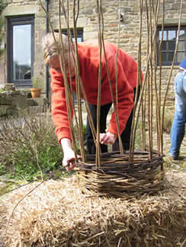
In May 2006, Borderland Voices launched Stepping Stones Arts, an innovative Arts on Referral project. Working in partnership with the local health care community we offered a range of creative arts activities for the benefit of referred clients and aim to promote a wider understanding of the benefits of arts activities for mental well-being. The Stepping Stones Arts project was inspired, in part, by the successful Exercise on Referral schemes, such as Healthy Walks, which have been running in the Moorlands and other parts of North Staffordshire for some years. Borderland Voices believes that involvement in the creative arts, within the context of a supportive group, can be just as effective as exercise in the first steps on the road to recovery. The Stepping Stones Arts strand of our work was designed to extend the range of our existing arts provision, to gather evidence of its benefits to referred clients and to spread the word to the wider community. The project was centred at our new base at Haregate, Leek and ran from May 2006 - September 2007. We have been successful in securing funding from ACE West Midlands, The Big Lottery Fund, Staffordshire County Arts and Staffordshire Moorlands District Council. Borderland Voices worked in partnership with primary and secondary care trusts, GPs, community psychiatric nurses, social services, psychiatric resource centres, healthy living networks and the healthcare community in general. We received strong messages of support from many quarters and very much look forward to further new collaborations.
Some examples of the Artworks created during the project
